Theodolite
# Source: AI Source: Provided by: [Data Path: Persons Table -> ID Column: 1, Name_En Column: Motasem Essam] -> From: [ChatGPT] on [7/17/2026]
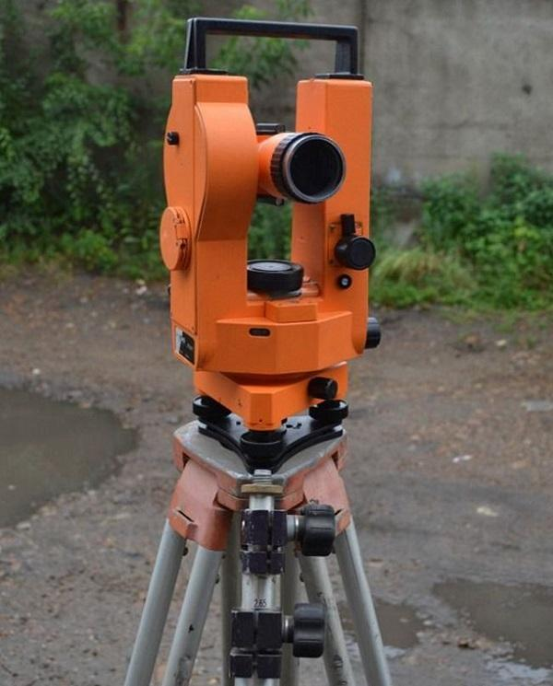
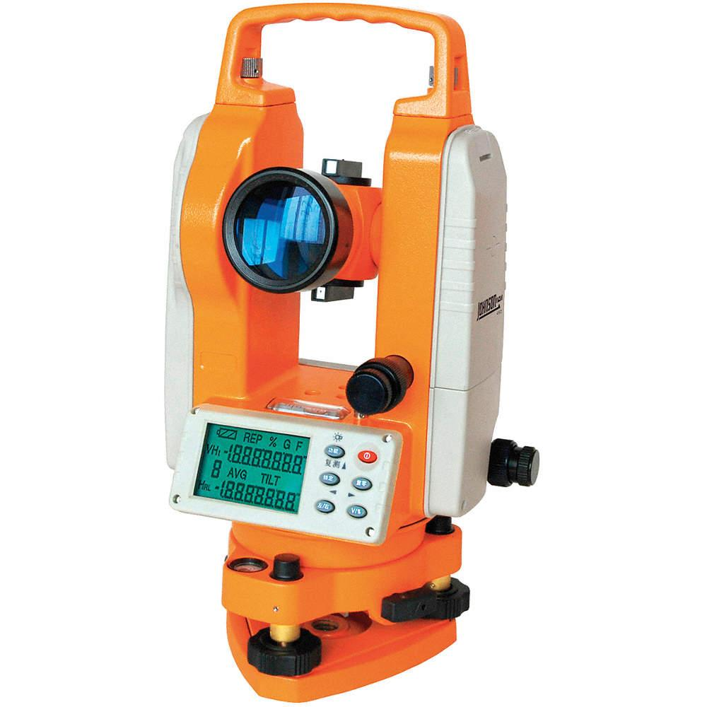
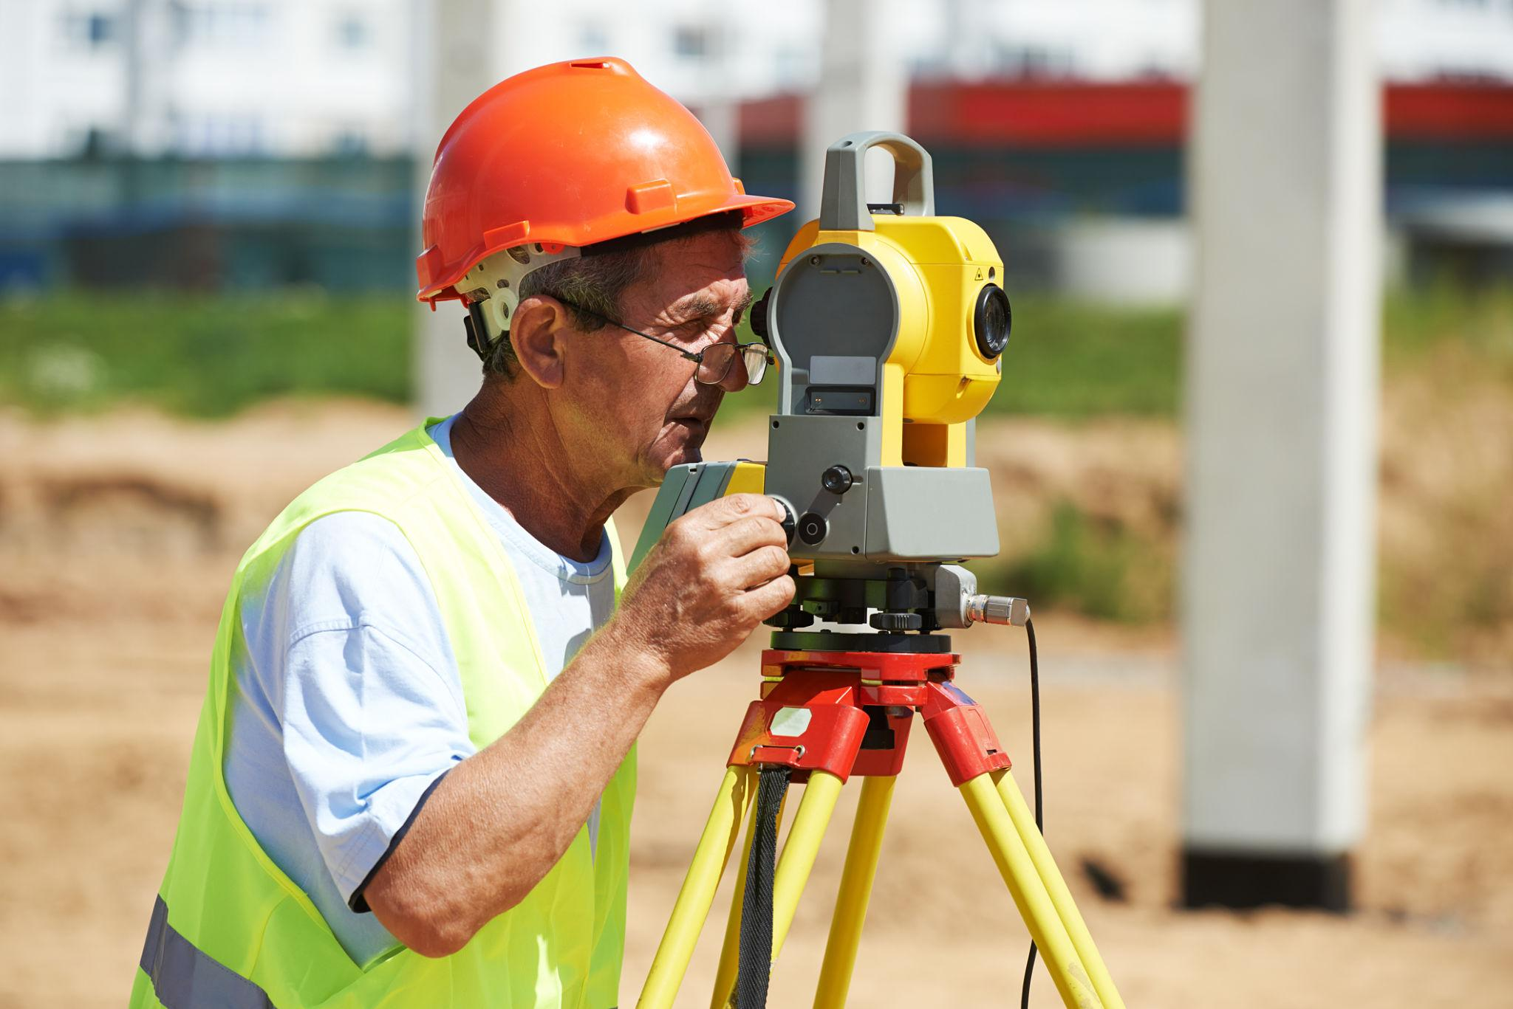
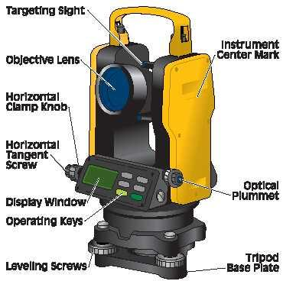
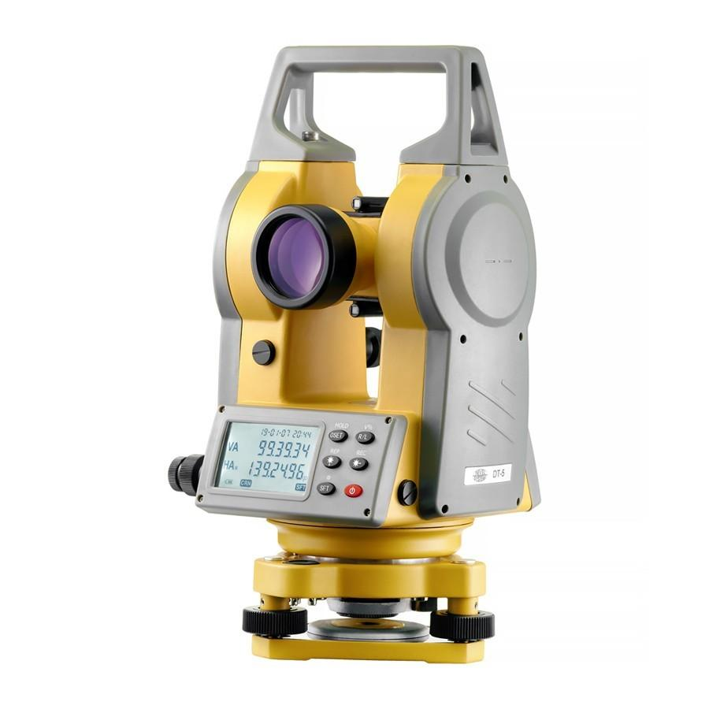
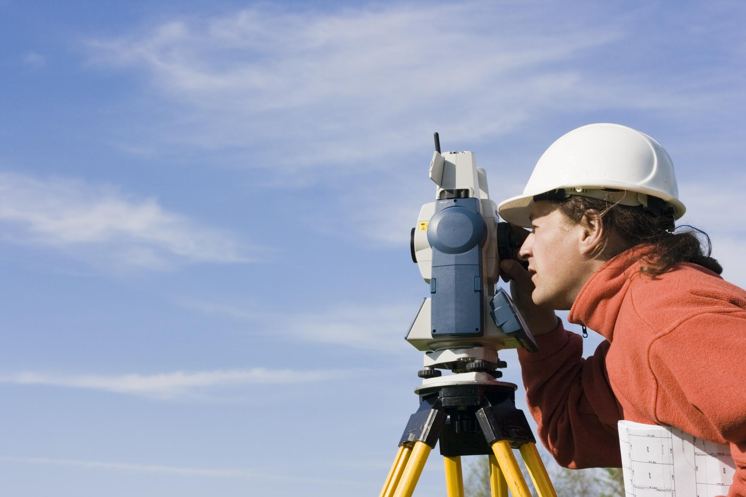
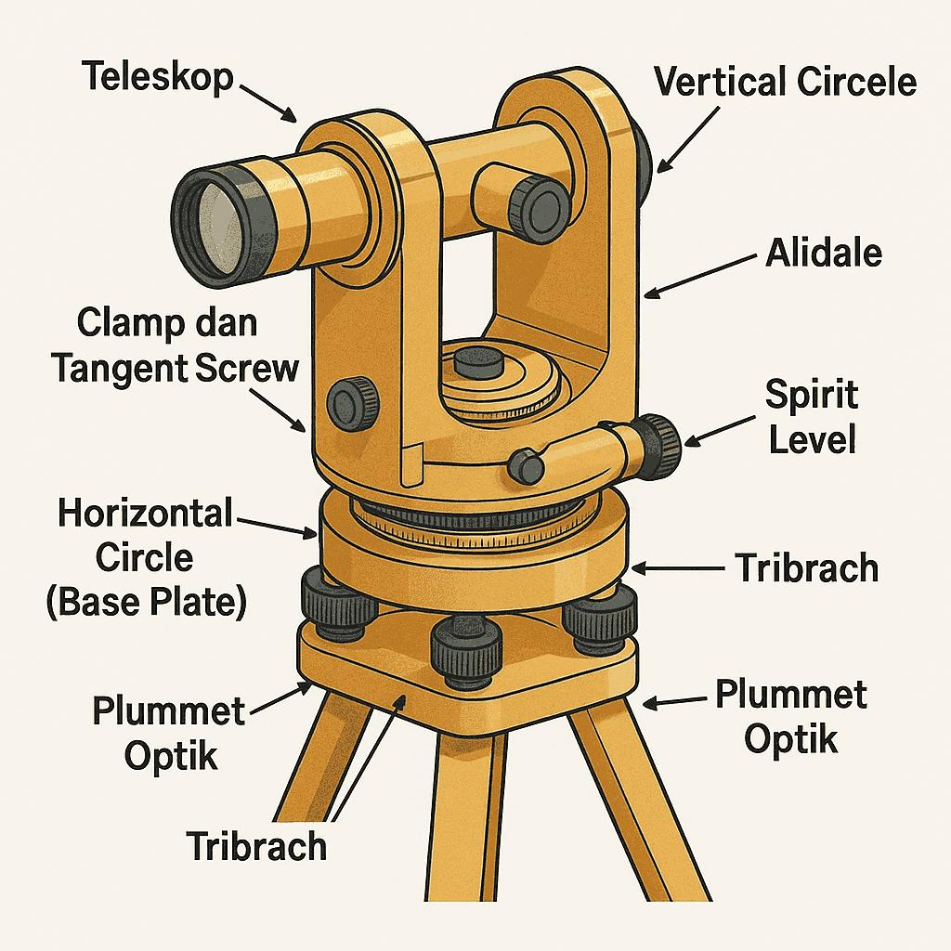
A Theodolite is a precision surveying instrument used to measure horizontal angles, vertical angles, and, with additional accessories, distances and elevations. It is one of the most important instruments in surveying, civil engineering, construction, mapping, mining, and geodesy.
Unlike a protractor or clinometer, which measure simple angles, a theodolite provides high-precision angular measurements, often accurate to a few arc-seconds.

Definition
# Source: AI Source: Provided by: [Data Path: Persons Table -> ID Column: 1, Name_En Column: Motasem Essam] -> From: [ChatGPT] on [7/17/2026]
A Theodolite is a precision optical or electronic instrument used to accurately measure horizontal and vertical angles in surveying, engineering, construction, and mapping.

Purpose
# Source: AI Source: Provided by: [Data Path: Persons Table -> ID Column: 1, Name_En Column: Motasem Essam] -> From: [ChatGPT] on [7/17/2026]
A theodolite is used to:
- Measure horizontal angles.
- Measure vertical angles.
- Establish straight survey lines.
- Determine land boundaries.
- Lay out buildings and roads.
- Measure elevations (with additional calculations).
- Support mapping and geodetic surveys.

Principle of Operation
# Source: AI Source: Provided by: [Data Path: Persons Table -> ID Column: 1, Name_En Column: Motasem Essam] -> From: [ChatGPT] on [7/17/2026]
A theodolite measures angles by rotating a telescope around two perpendicular axes:
- Horizontal axis → measures vertical angles.
- Vertical axis → measures horizontal angles.
Graduated circles (optical or electronic encoders) record the angle of rotation with very high precision.

Main Components
# Source: AI Source: Provided by: [Data Path: Persons Table -> ID Column: 1, Name_En Column: Motasem Essam] -> From: [ChatGPT] on [7/17/2026]
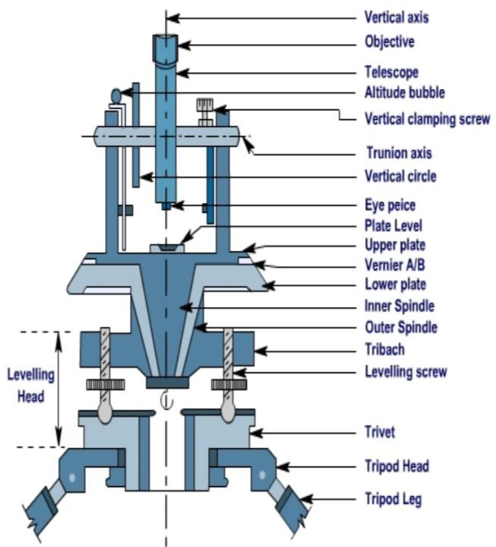
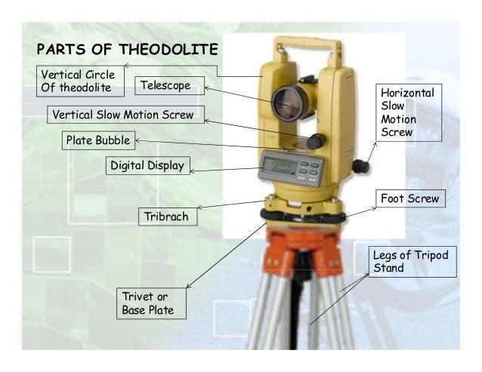
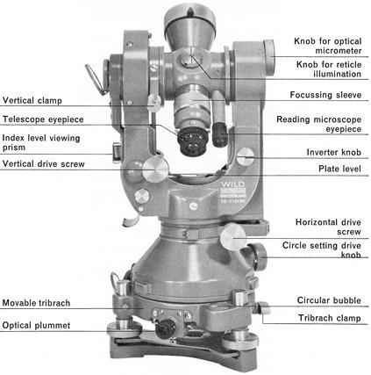

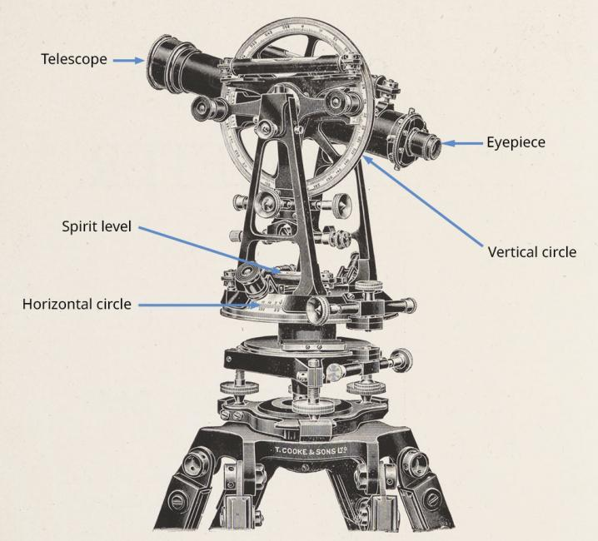
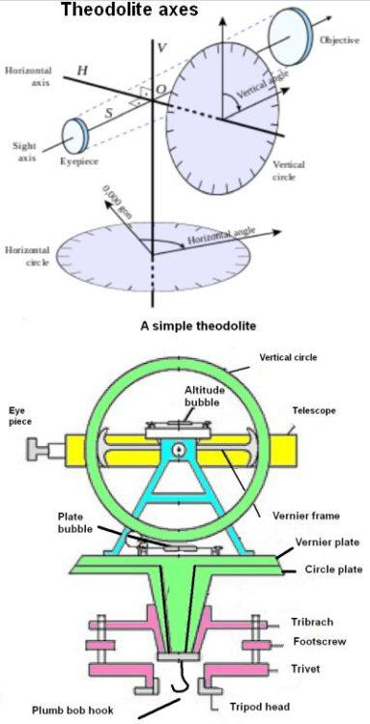
A typical theodolite consists of:
- Telescope
- Eyepiece
- Objective lens
- Horizontal circle
- Vertical circle
- Angle display or vernier scale
- Level bubble (spirit level)
- Leveling screws (foot screws)
- Tribrach (base)
- Tripod
- Horizontal clamp and tangent screw
- Vertical clamp and tangent screw

Types of Theodolites

1. Optical (Transit) Theodolite
# Source: AI Source: Provided by: [Data Path: Persons Table -> ID Column: 1, Name_En Column: Motasem Essam] -> From: [ChatGPT] on [7/17/2026]
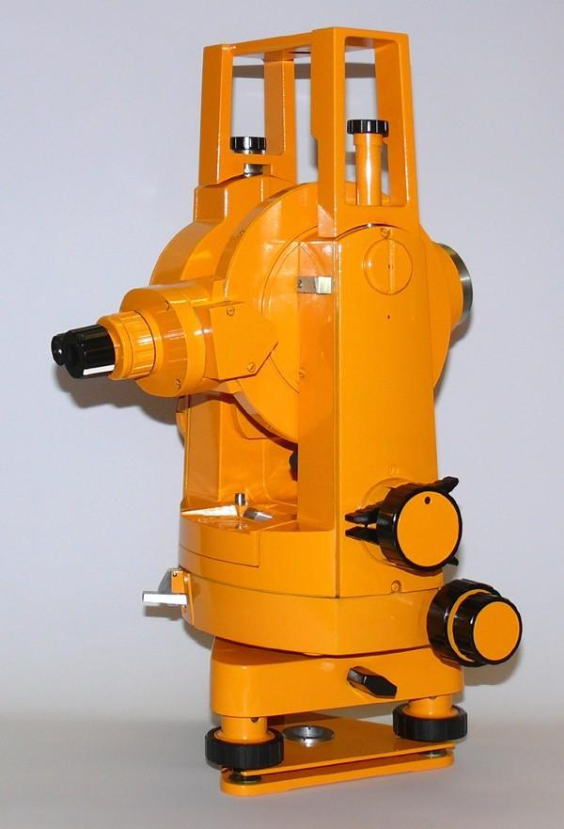
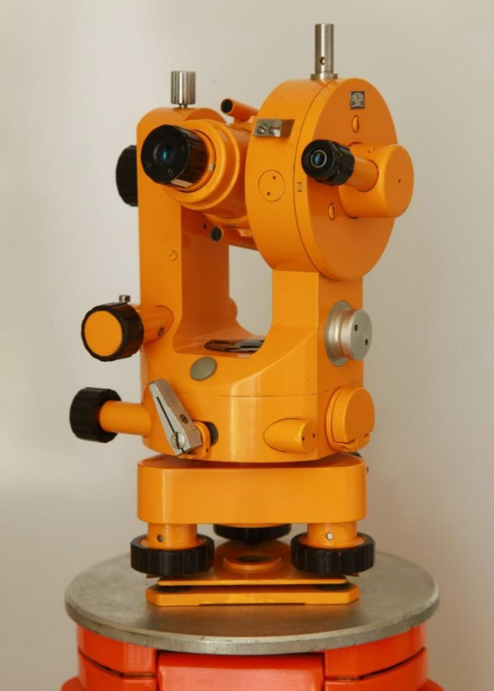
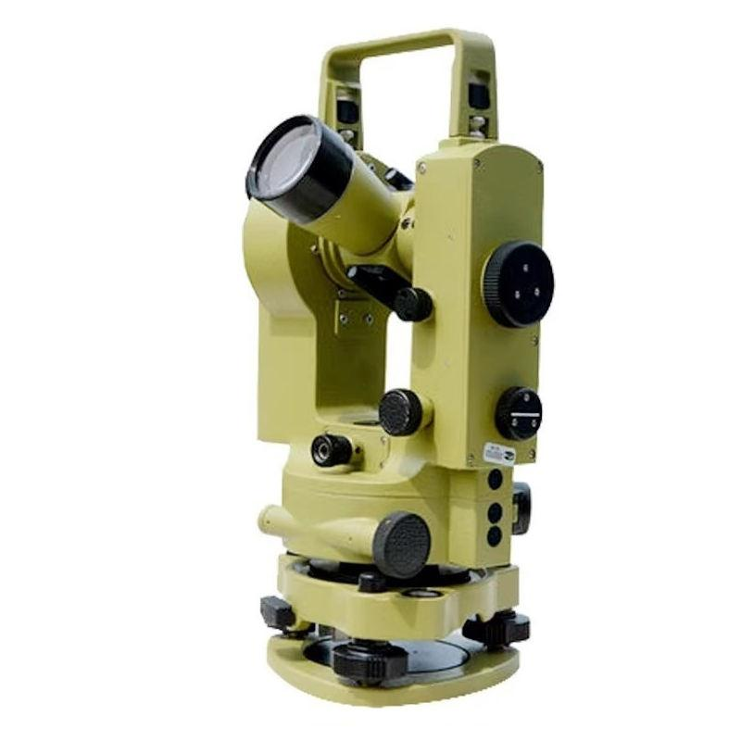
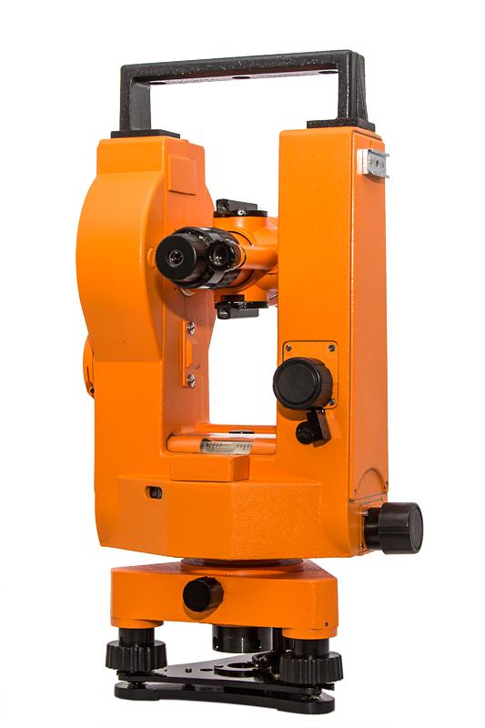
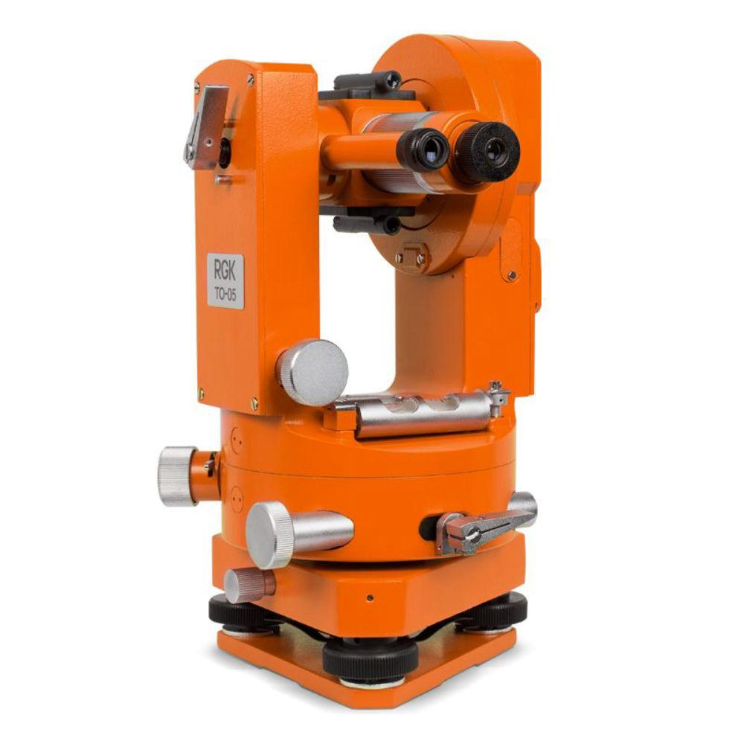
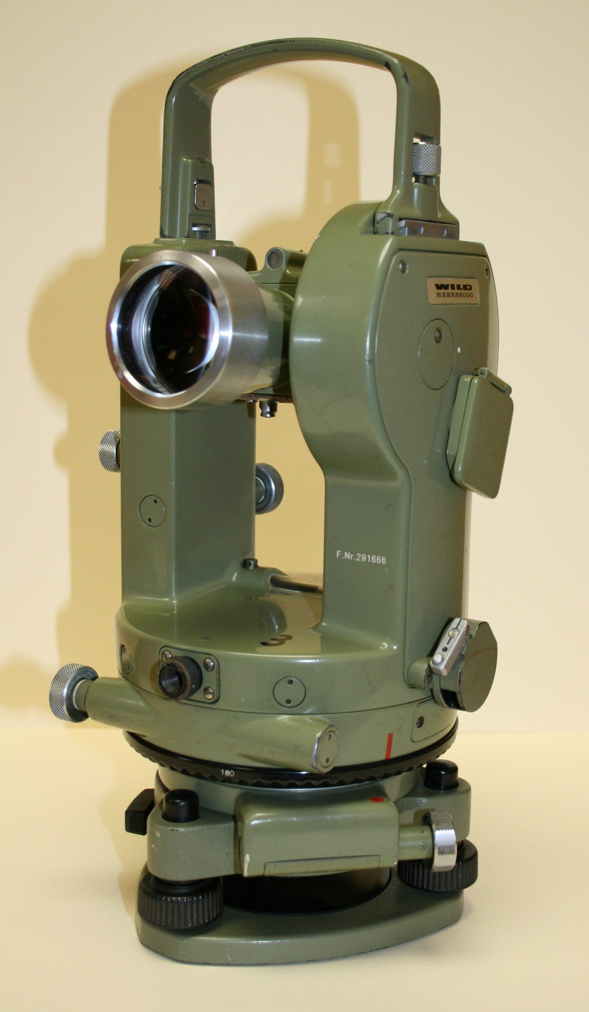
Description
Uses optical vernier scales for angle readings.
Features
- No electronic display
- Manual reading
- High durability
Applications
- Traditional surveying
- Education
- Field measurements

2. Electronic (Digital) Theodolite
# Source: AI Source: Provided by: [Data Path: Persons Table -> ID Column: 1, Name_En Column: Motasem Essam] -> From: [ChatGPT] on [7/17/2026]


Description
Uses electronic sensors to display angle measurements digitally.
Features
- LCD display
- High accuracy
- Faster readings
- Reduced reading errors
Applications
- Modern surveying
- Civil engineering
- Construction

3. Repeating Theodolite
# Source: AI Source: Provided by: [Data Path: Persons Table -> ID Column: 1, Name_En Column: Motasem Essam] -> From: [ChatGPT] on [7/17/2026]
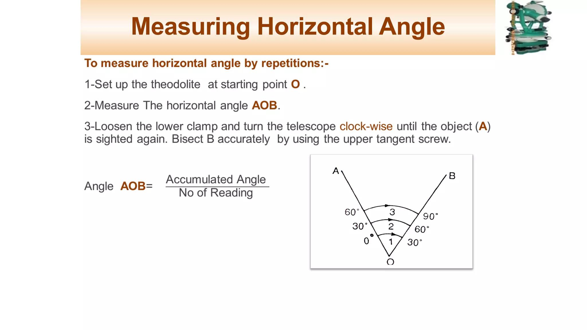
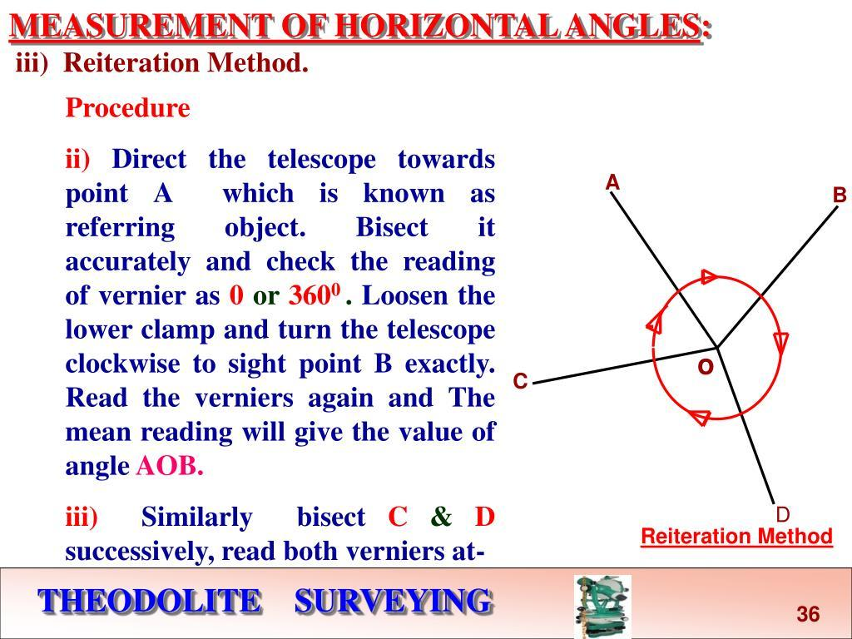
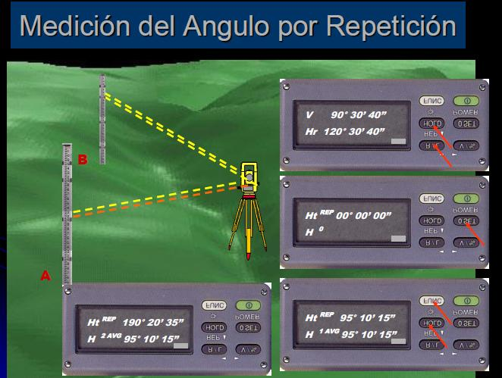
Description
Measures the same angle multiple times and averages the result to improve accuracy.
Applications
- Precision surveying
- Engineering projects

4. Direction Theodolite
# Source: AI Source: Provided by: [Data Path: Persons Table -> ID Column: 1, Name_En Column: Motasem Essam] -> From: [ChatGPT] on [7/17/2026]
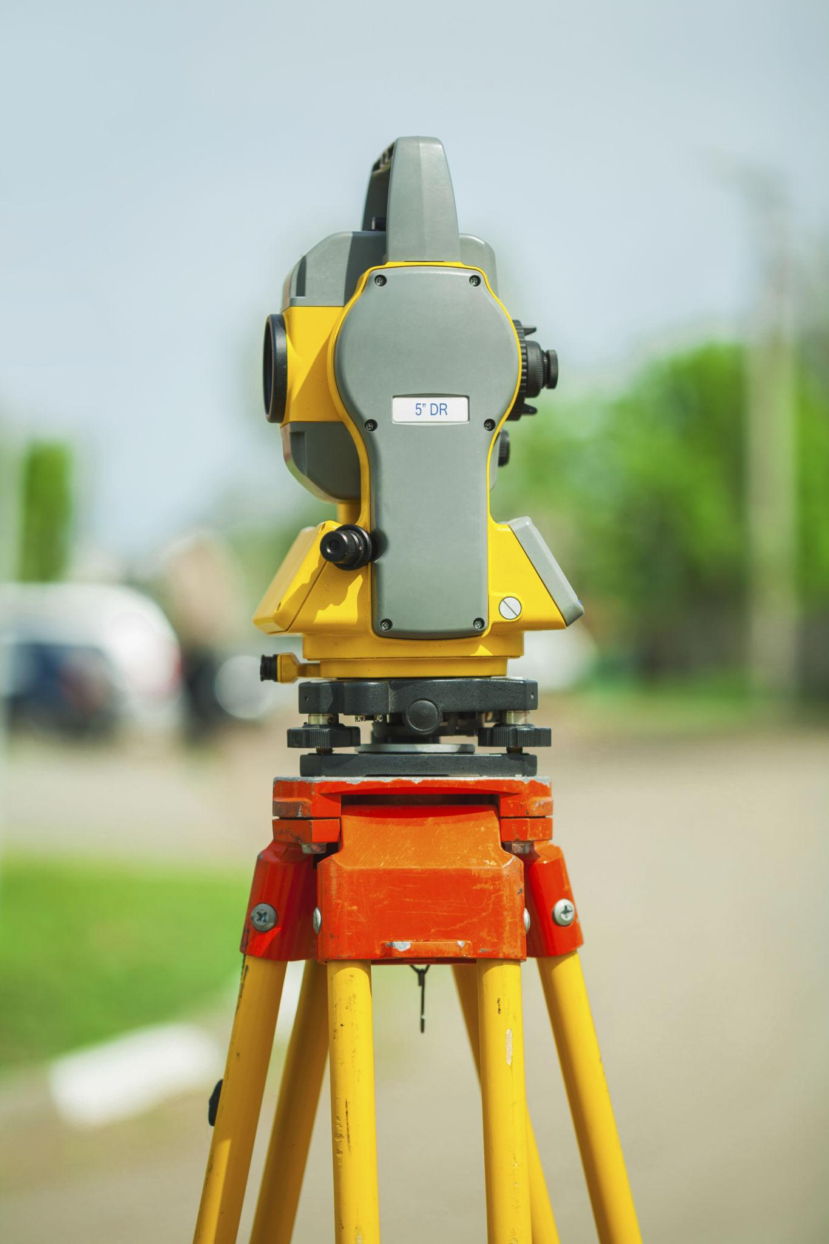
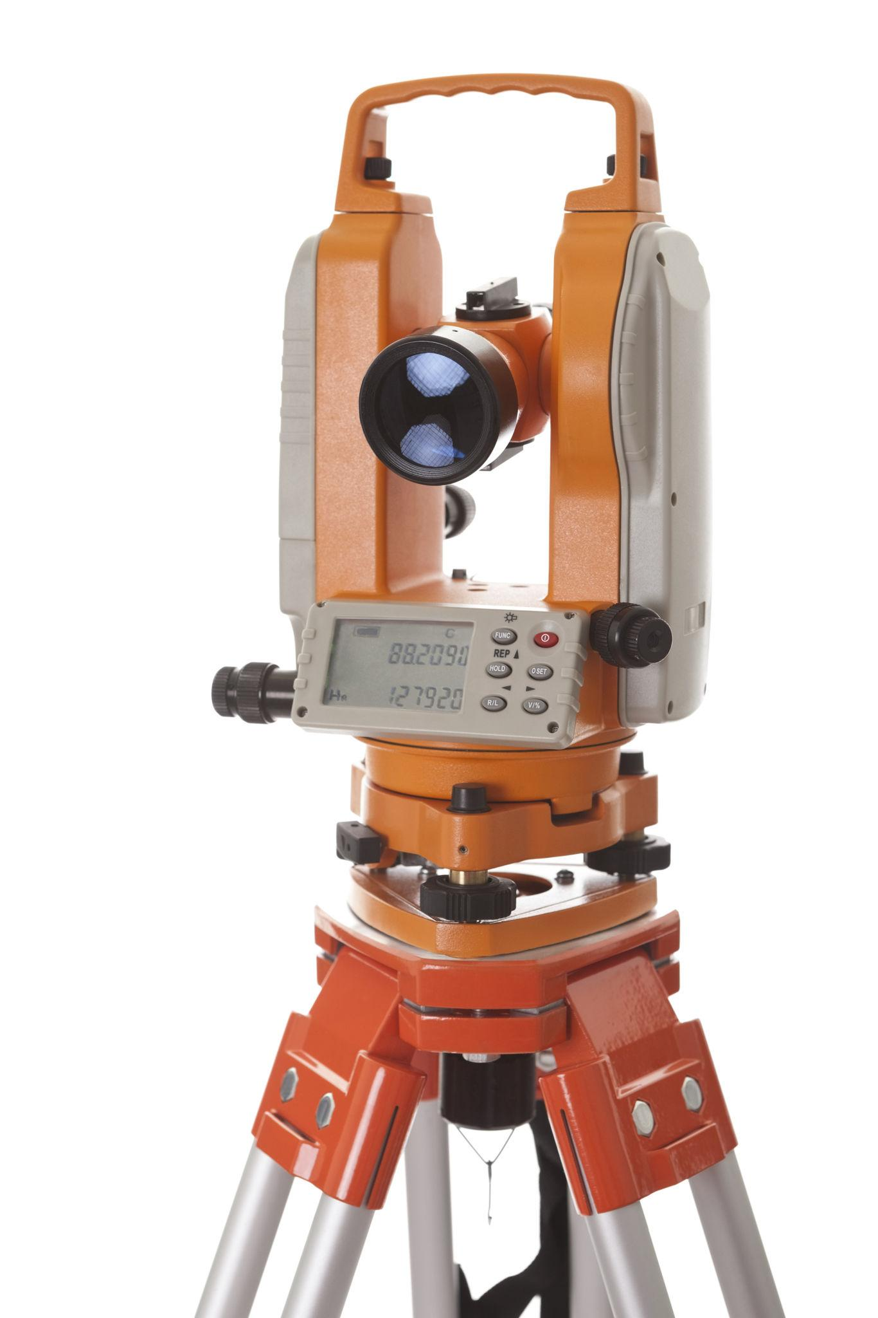
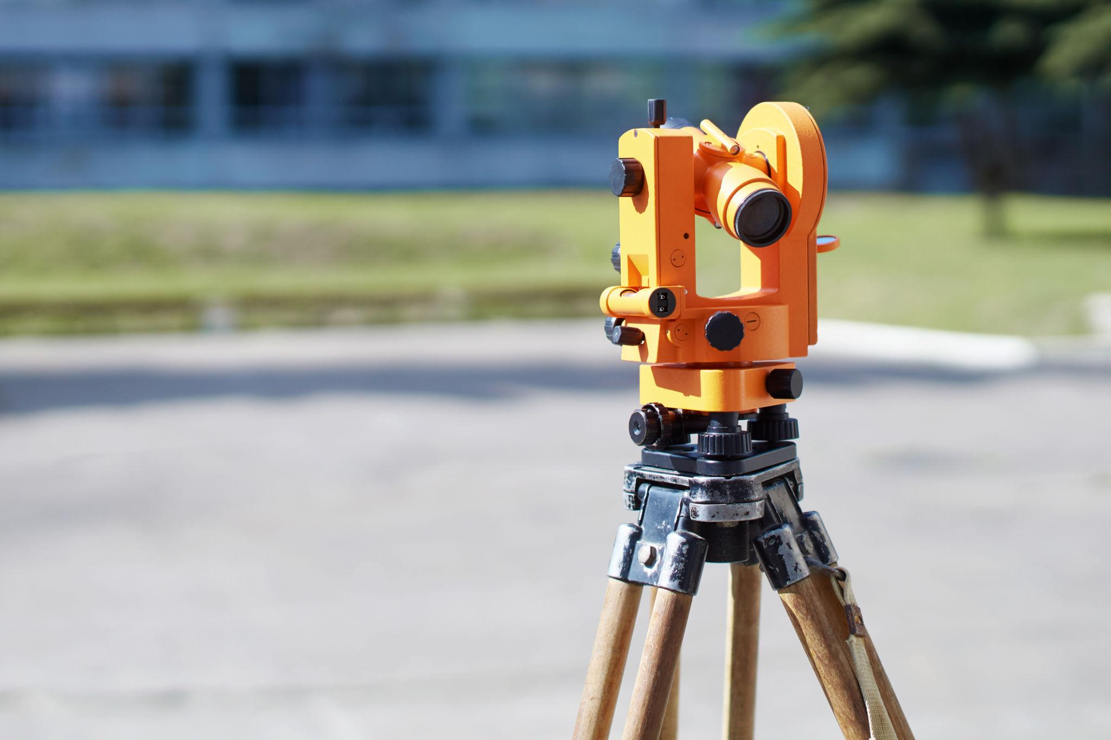

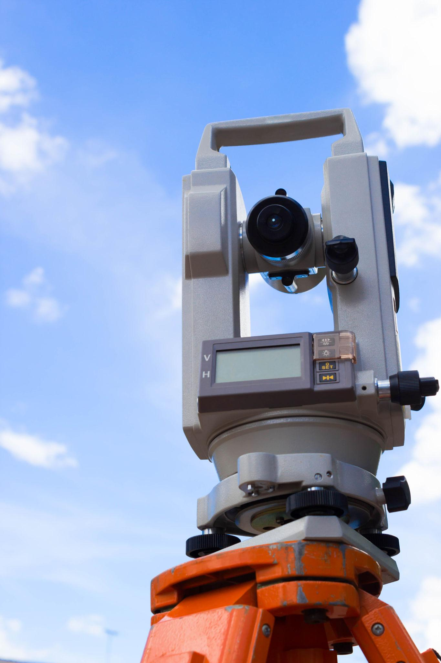
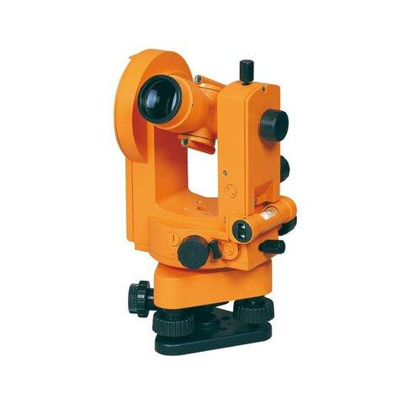
Description
Measures multiple directions from a single station without resetting the horizontal circle.
Applications
- Geodetic surveys
- Large mapping projects

Measuring Units
# Source: AI Source: Provided by: [Data Path: Persons Table -> ID Column: 1, Name_En Column: Motasem Essam] -> From: [ChatGPT] on [7/17/2026]
A theodolite measures angles in:
- Degrees (°)
- Minutes (′)
- Seconds (″)
Some electronic models also support:
- Gradians (gon)
- Mils

Measuring Range
# Source: AI Source: Provided by: [Data Path: Persons Table -> ID Column: 1, Name_En Column: Motasem Essam] -> From: [ChatGPT] on [7/17/2026]
Typical ranges:
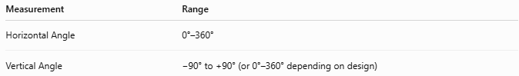
Measurement | Range
Horizontal Angle | 0°–360°
Vertical Angle | −90° to +90° (or 0°–360° depending on design)

Resolution
# Source: AI Source: Provided by: [Data Path: Persons Table -> ID Column: 1, Name_En Column: Motasem Essam] -> From: [ChatGPT] on [7/17/2026]
Typical resolutions:
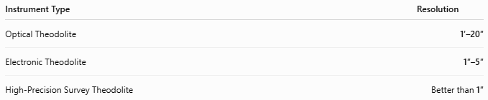
Instrument Type | Resolution
Optical Theodolite | 1′–20″
Electronic Theodolite | 1″–5″
High-Precision Survey Theodolite | Better than 1″

How to Use a Theodolite
# Source: AI Source: Provided by: [Data Path: Persons Table -> ID Column: 1, Name_En Column: Motasem Essam] -> From: [ChatGPT] on [7/17/2026]
- Mount the theodolite on a tripod.
- Level the instrument using the leveling screws and bubble.
- Center it over the survey point.
- Aim the telescope at the first target.
- Set or record the initial angle.
- Rotate to the second target.
- Read the horizontal or vertical angle.
- Record the measurement.

Example
# Source: AI Source: Provided by: [Data Path: Persons Table -> ID Column: 1, Name_En Column: Motasem Essam] -> From: [ChatGPT] on [7/17/2026]
Suppose:
Initial direction:
0° 00′ 00″
Second direction:
45° 18′ 24″
Measured horizontal angle:
45° 18′ 24″

Accuracy
# Source: AI Source: Provided by: [Data Path: Persons Table -> ID Column: 1, Name_En Column: Motasem Essam] -> From: [ChatGPT] on [7/17/2026]
Accuracy depends on:
- Instrument quality
- Proper leveling
- Calibration
- Atmospheric conditions
- Operator skill
Professional theodolites commonly achieve 1–5 arc-second accuracy.

Sources of Error
# Source: AI Source: Provided by: [Data Path: Persons Table -> ID Column: 1, Name_En Column: Motasem Essam] -> From: [ChatGPT] on [7/17/2026]
Instrument Errors
- Collimation error
- Circle graduation error
- Optical misalignment
- Calibration drift

Observation Errors
- Improper focusing
- Incorrect reading
- Poor target centering

Environmental Errors
- Wind vibration
- Heat shimmer
- Atmospheric refraction
- Ground instability

Applications
# Source: AI Source: Provided by: [Data Path: Persons Table -> ID Column: 1, Name_En Column: Motasem Essam] -> From: [ChatGPT] on [7/17/2026]
Theodolites are used in:
- Land surveying
- Construction
- Civil engineering
- Highway design
- Railway construction
- Tunnel alignment
- Mining
- Geodesy
- Archaeology
- Mapping

Advantages
# Source: AI Source: Provided by: [Data Path: Persons Table -> ID Column: 1, Name_En Column: Motasem Essam] -> From: [ChatGPT] on [7/17/2026]
A theodolite:
- Provides extremely accurate angle measurements.
- Measures both horizontal and vertical angles.
- Is suitable for long-distance surveying.
- Supports engineering layout work.
- Electronic models reduce reading errors.

Limitations
# Source: AI Source: Provided by: [Data Path: Persons Table -> ID Column: 1, Name_En Column: Motasem Essam] -> From: [ChatGPT] on [7/17/2026]
A theodolite:
- Requires careful leveling.
- Needs operator training.
- Electronic models require batteries.
- Does not directly measure distance unless combined with additional equipment (such as an EDM or total station).

Comparison with Other Angle Measuring Instruments
# Source: AI Source: Provided by: [Data Path: Persons Table -> ID Column: 1, Name_En Column: Motasem Essam] -> From: [ChatGPT] on [7/17/2026]
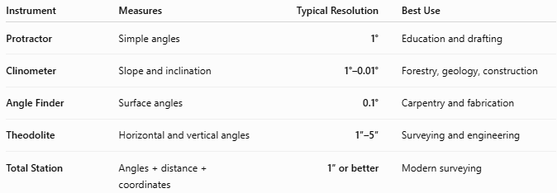
Instrument | Measures | Typical Resolution | Best Use
Protractor | Simple angles | 1° | Education and drafting
Clinometer | Slope and inclination | 1°–0.01° | Forestry, geology, construction
Angle Finder | Surface angles | 0.1° | Carpentry and fabrication
Theodolite | Horizontal and vertical angles | 1″–5″ | Surveying and engineering
Total Station | Angles + distance + coordinates | 1″ or better | Modern surveying

Care and Maintenance
# Source: AI Source: Provided by: [Data Path: Persons Table -> ID Column: 1, Name_En Column: Motasem Essam] -> From: [ChatGPT] on [7/17/2026]
To maintain precision:
- Transport in a protective case.
- Keep lenses clean.
- Avoid shocks and vibrations.
- Store in a dry environment.
- Calibrate periodically.
- Protect from dust and moisture.

Common Mistakes
# Source: AI Source: Provided by: [Data Path: Persons Table -> ID Column: 1, Name_En Column: Motasem Essam] -> From: [ChatGPT] on [7/17/2026]
- Failing to level the instrument.
- Incorrect centering over the survey point.
- Reading the wrong circle.
- Poor focusing.
- Ignoring atmospheric effects during long-distance measurements.

Key Points
# Source: AI Source: Provided by: [Data Path: Persons Table -> ID Column: 1, Name_En Column: Motasem Essam] -> From: [ChatGPT] on [7/17/2026]
- A Theodolite is a precision surveying instrument.
- It measures:
  - Horizontal angles
  - Vertical angles
- Common types:
  - Optical Theodolite
  - Electronic Theodolite
  - Repeating Theodolite
  - Direction Theodolite
- Typical accuracy:
  - 1–5 arc-seconds
- Used extensively in surveying, civil engineering, construction, mining, and mapping.

Conclusion
# Source: AI Source: Provided by: [Data Path: Persons Table -> ID Column: 1, Name_En Column: Motasem Essam] -> From: [ChatGPT] on [7/17/2026]
A Theodolite is one of the most accurate and widely used instruments for measuring horizontal and vertical angles in surveying and engineering. By combining a precision telescope with finely graduated angular measurement systems, it enables surveyors and engineers to establish accurate alignments, determine land boundaries, construct infrastructure, and produce detailed maps. Although many modern projects now use total stations, the theodolite remains a fundamental instrument for understanding and performing precise angular measurements in both education and professional surveying.

